BRAND SYSTEM
OBELISK
RX
Sunset Precision
Clinical confidence. Refined warmth. Modern research.
Developer-ready visual standards for web, ecommerce, email and digital marketing
ObeliskRX LLC • Boca Raton, Florida

1. Brand Foundation
The ObeliskRX visual identity should feel precise enough for a clinical research company and distinctive enough to avoid blending into the sea of generic blue peptide brands.

Brand positioning
Attribute | Direction | Avoid
Clinical | Clean grids, clear hierarchy, documented information | Hospital-cold, sterile, or generic medical stock design
Prestige | Dark navy, generous space, restrained details | Gold-heavy luxury, glossy effects, visual clutter
Modern | Crisp typography, subtle gradients, structured components | Futuristic neon, sci-fi DNA overload, AI-looking imagery
Warm | Sunset orange used as a focused human accent | Orange-dominant pages or beach/sunset lifestyle cues

Brand personality
- Confident, not loud
- Scientific, not intimidating
- Elegant, not ornate
- Warm, not casual
- Transparent, not promotional

Recommended color balance
Approved website balance: approximately 70% warm ivory/white, 20% deep navy/blue and 10% orange accents. The homepage hero is the primary dark sunset moment; content sections below it should remain light, spacious and clinical.

2. Core Color Palette
This is the approved sunset palette. Developers should use these values exactly rather than choosing visually similar colors.
Obelisk Midnight | #0B1F3A | Primary dark background, headings, footer, navigation
Clinical Blue | #174A7E | Primary brand blue, links, secondary buttons
Horizon Blue | #6FA9D8 | Data accents, subtle illustrations, hover highlights
Victory Orange | #F47A38 | Primary CTA, active states, emphasis
Sunset Amber | #FFB15A | Gradient highlight and small decorative accents
Warm Ivory | #F7F3EC | Approved primary website background
White | #FFFFFF | Cards and clean content surfaces
Ink | #17212B | Body text on light backgrounds

Color specifications
Color | HEX | RGB | CMYK*
Obelisk Midnight | #0B1F3A | 11, 31, 58 | 81, 47, 0, 77
Clinical Blue | #174A7E | 23, 74, 126 | 82, 41, 0, 51
Horizon Blue | #6FA9D8 | 111, 169, 216 | 49, 22, 0, 15
Victory Orange | #F47A38 | 244, 122, 56 | 0, 50, 77, 4
Sunset Amber | #FFB15A | 255, 177, 90 | 0, 31, 65, 0
Warm Ivory | #F7F3EC | 247, 243, 236 | 0, 2, 4, 3
*CMYK values are process approximations. Request a physical proof and printer-specific conversion for packaging.

3. Sunset Gradient System

Signature gradient
Use the signature gradient selectively on hero backgrounds, thin section dividers, icon details or premium campaign moments. Do not place it behind long body copy.
0%  #0B1F3A | 38%  #174A7E | 76%  #F47A38 | 100%  #FFB15A
CSS: linear-gradient(115deg, #0B1F3A 0%, #174A7E 38%, #F47A38 76%, #FFB15A 100%);

Approved secondary gradients
Name | CSS value | Best use
Blue depth | linear-gradient(135deg, #0B1F3A, #174A7E) | Navigation, footer, dark cards
Sunset glow | linear-gradient(135deg, #F47A38, #FFB15A) | Small CTA detail, badges, decorative glow
Soft horizon | linear-gradient(135deg, #F7F3EC, #EEF5FA) | Light section background, research pages

Gradient rules
- Keep the main page background solid or softly neutral; gradients are moments, not wallpaper.
- Do not use rainbow, neon, purple or pink additions.
- Use white text only over the navy/blue portion. Reposition text or add a navy overlay if it crosses the orange/amber area.
- Avoid placing the gradient inside every button, card and heading. One strong gradient moment per viewport is enough.

4. Typography
Recommended web pairing: Manrope for headings and Inter for body copy. Both are modern, highly legible and available through Google Fonts. If the final logo uses a proprietary expanded typeface, keep that font limited to the logo artwork.
Role | Typeface | Weight | Desktop size / line height
Display / H1 | Manrope | 700 | 52px / 1.08
H2 | Manrope | 650–700 | 38px / 1.15
H3 | Manrope | 650 | 28px / 1.2
H4 / card title | Manrope | 600 | 20px / 1.3
Body large | Inter | 400 | 18px / 1.65
Body | Inter | 400 | 16px / 1.6
Label / navigation | Inter | 600 | 14px / 1.3
Fine print | Inter | 400 | 12–13px / 1.5

Type behavior
- Use sentence case for headings. Avoid long passages in ALL CAPS.
- Limit text measure to 65–75 characters for readability.
- Use Manrope letter spacing between −0.02em and 0; use +0.04em only for small uppercase labels.
- Use orange for short labels or highlights, never for body paragraphs.
- On mobile, scale H1 to 36–40px and H2 to 28–32px. Body text must remain at least 16px.

Logo typography note
The wordmark is artwork, not live text. The developer should use the approved SVG logo file and must not recreate OBELISKRX with a substitute font.

Approved typography example
Use Manrope for display and section headings. Use Inter for navigation, buttons, body copy, product information, COA tables and supporting labels. The example below demonstrates the approved hierarchy within the sunset-and-ivory website system.
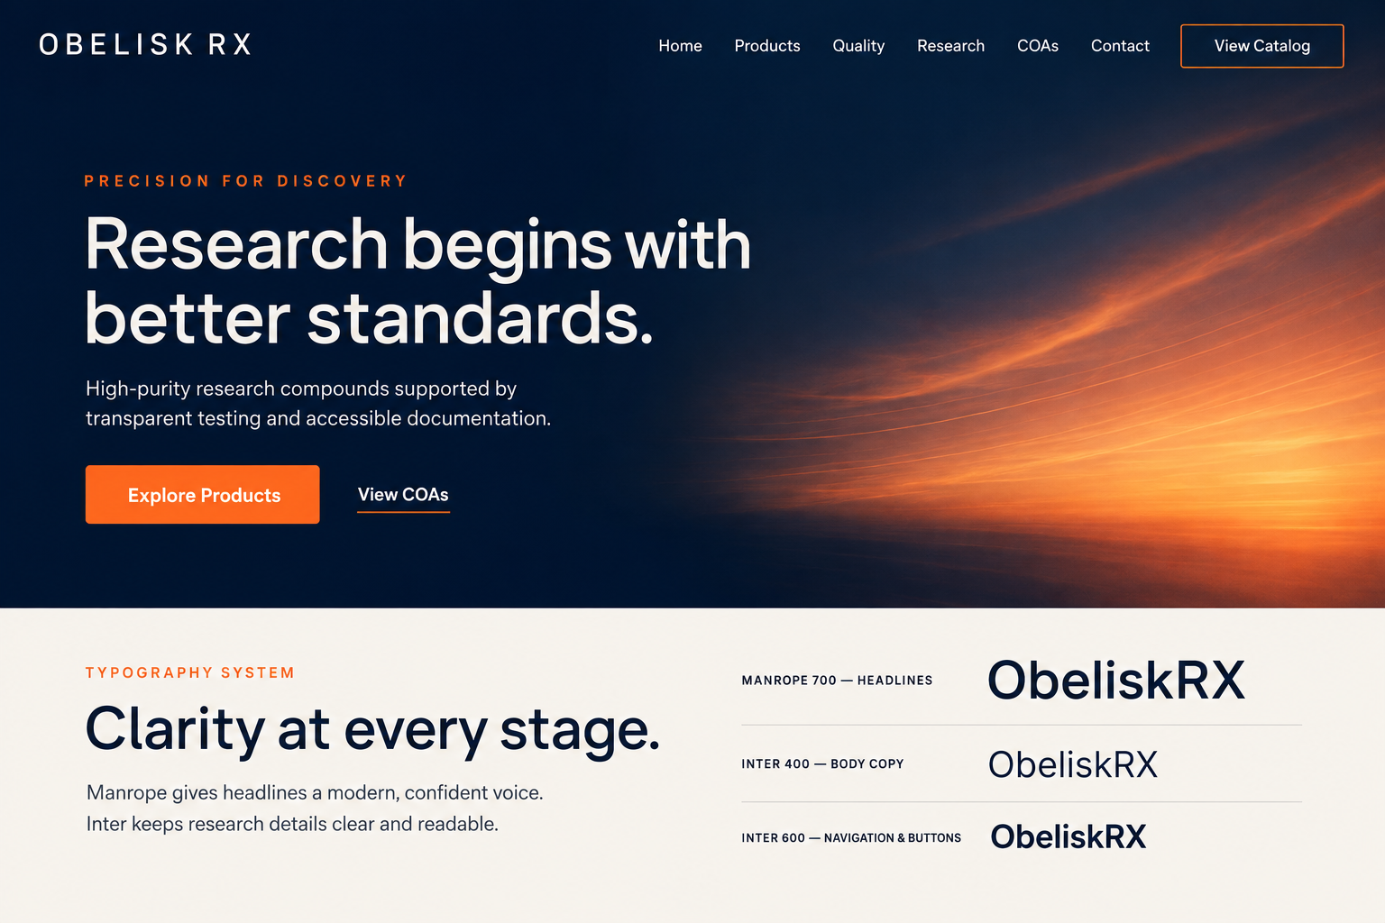
Final selection: Manrope + Inter. Avenir Next and Sora were reviewed as alternatives but are not part of the approved production system.

5. Website UI System

Surfaces and hierarchy
Element | Approved treatment
Page background | Warm Ivory #F7F3EC; alternate selected sections in White #FFFFFF
Primary text | Obelisk Midnight #0B1F3A for headings; Ink #17212B for body copy
Dark sections | Reserve Obelisk Midnight for the sunset hero, footer and selected emphasis
Cards | White, 1px #D9E0E7 border, 14–18px radius, subtle shadow
Dividers | 1px #D9E0E7; optional 2–3px orange accent on featured content
Links | Clinical Blue; underline on hover and keyboard focus

Buttons
Style | Default | Hover / focus
Primary | Victory Orange background; Midnight text; 600 weight | Darken to #D96529; visible 3px blue focus ring
Secondary | Clinical Blue background; white text | Midnight background; visible focus ring
Outline | Transparent; 1.5px Clinical Blue; blue text | Soft Horizon fill; Midnight text
On dark | White or orange button; never low-contrast blue on navy | Increase contrast, not just color saturation

Spacing and shape
- Use an 8px spacing system: 8, 16, 24, 32, 48, 64, 96px.
- Buttons: 48–52px minimum height, 16–22px horizontal padding, 10–12px radius.
- Cards: 24–32px internal padding. Major sections: 72–112px vertical padding on desktop.
- Keep rounded corners refined. Avoid pill shapes everywhere; reserve pills for tags and filters.
- Use subtle shadows: 0 10px 30px rgba(11,31,58,.08).

6. Accessibility & Compliance
Accessibility is part of the brand. Premium design that users cannot read or navigate is failed design.
Pairing | Approx. contrast | Use
White on Obelisk Midnight | 16.7:1 | Pass — all text
White on Clinical Blue | 9.1:1 | Pass — all text
Ink on Warm Ivory | 14.7:1 | Pass — all text
Midnight on Victory Orange | 6.1:1 | Pass — all text
White on Victory Orange | 2.8:1 | Fail — do not use for normal text
White on Sunset Amber | 1.8:1 | Fail — do not use for text

Required implementation rules
- Meet WCAG 2.2 AA: 4.5:1 for normal text and 3:1 for large text and interface components.
- Never communicate status by color alone. Add text, icons or patterns.
- Keyboard focus must always be visible. Do not remove outline without a replacement.
- All meaningful images need accurate alt text; decorative gradient shapes should use empty alt text or CSS backgrounds.
- Respect prefers-reduced-motion. Avoid autoplay animation and parallax that cannot be disabled.
- Forms need persistent labels, clear errors and instructions. Placeholder text is not a label.

7. Homepage Visual Direction
Approved direction: a simple, abstract blue-and-orange sunset is the homepage hero image. It is the primary emotional brand signature and should be used without vials, glassware, laboratory props, molecules, people or landmarks.

Hero implementation
- Use the sunset as a full-width CSS background image with background-size: cover and background-position: center.
- Keep the darkest navy area behind the navigation, headline and supporting copy; keep the orange glow primarily on the right.
- Add a subtle navy overlay only if needed for consistent text contrast. Do not flatten or oversaturate the sunset.
- Desktop hero height: approximately 680–820px. Mobile hero height: content-driven, with a minimum near 640px.
- Place one primary orange CTA and one restrained secondary text or outline action in the hero.
- The hero must end in a soft peach-to-ivory atmospheric fade. Avoid a hard horizontal cut into the next section.

Light-page continuation
- Use Warm Ivory #F7F3EC as the dominant page canvas below the hero.
- Alternate with white only when it improves section separation; avoid cool gray page backgrounds.
- Use white cards with fine blue-gray borders, minimal shadow and generous internal spacing.
- Use deep navy headings, Ink body copy and orange only for labels, links, active states and primary actions.
- Recommended first section: a centered navy headline with three equal trust or quality cards.
- Do not repeat the sunset photograph in every section. One strong hero moment is enough.

8. Approved Homepage Example
The mockup below is the approved visual reference for balance, hierarchy and the transition from the sunset hero into the light website. It is directional—not final production artwork. Replace the sample wordmark with the approved SVG logo and publish only claims that match actual operations.
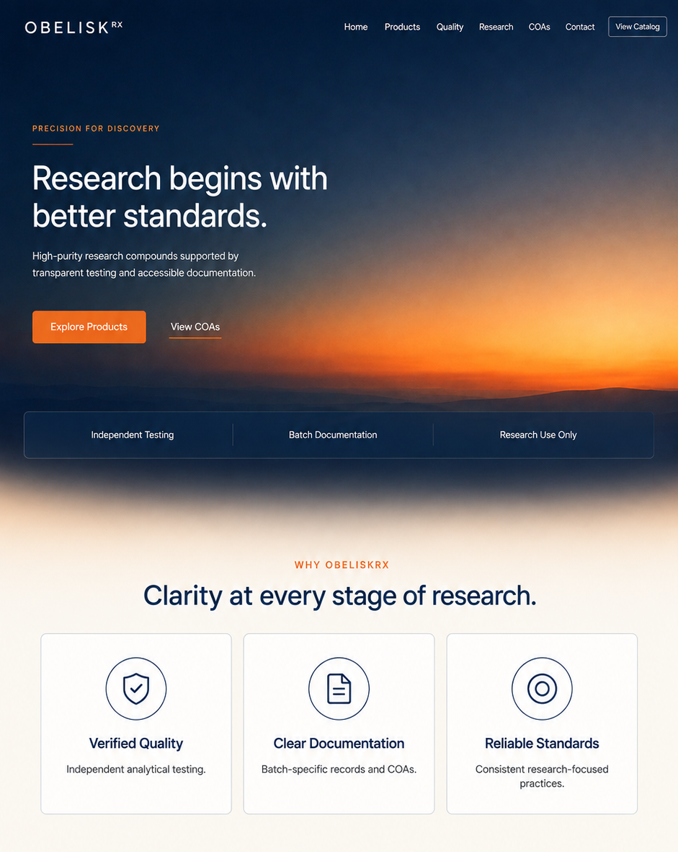
Developer priority: preserve the visual ratio—sunset hero first, then predominantly warm-ivory and white content sections with navy typography and restrained orange accents.

9. Interior-Page Sunset Heroes
Interior pages use coordinated atmospheric gradients rather than unrelated stock photography. Each gradient represents a different stage of the same sunset, keeping the website unified without repeating the homepage image.
  COA PAGE  Darkest and most controlled. Use for verification, documentation and batch records. |   RESEARCH ARTICLES  Muted blue-violet and peach. Use for thoughtful, editorial research content. |   ABOUT US  Lighter and warmer. Use for a welcoming, transparent brand introduction.

Interior hero rules
- Use a shorter hero height of approximately 360–480px on desktop.
- Keep the copy on the darker side of each image and verify contrast at every breakpoint.
- Use white text on COA and Research heroes; the lighter About Us version may require Midnight Navy text depending on crop.
- Do not add objects, visible sun disks, beaches, palm trees, vials, molecules or laboratory props.
- Export each image as WebP with a JPEG fallback and create a separate mobile crop.
- Use the homepage sunset only on the homepage. Interior gradients must remain quieter and simpler.

10. Approved Light Background System
Warm Ivory is the primary website canvas. White creates separation for cards and selected sections; Midnight Navy anchors headings and the footer; Victory Orange signals primary actions and small moments of emphasis.
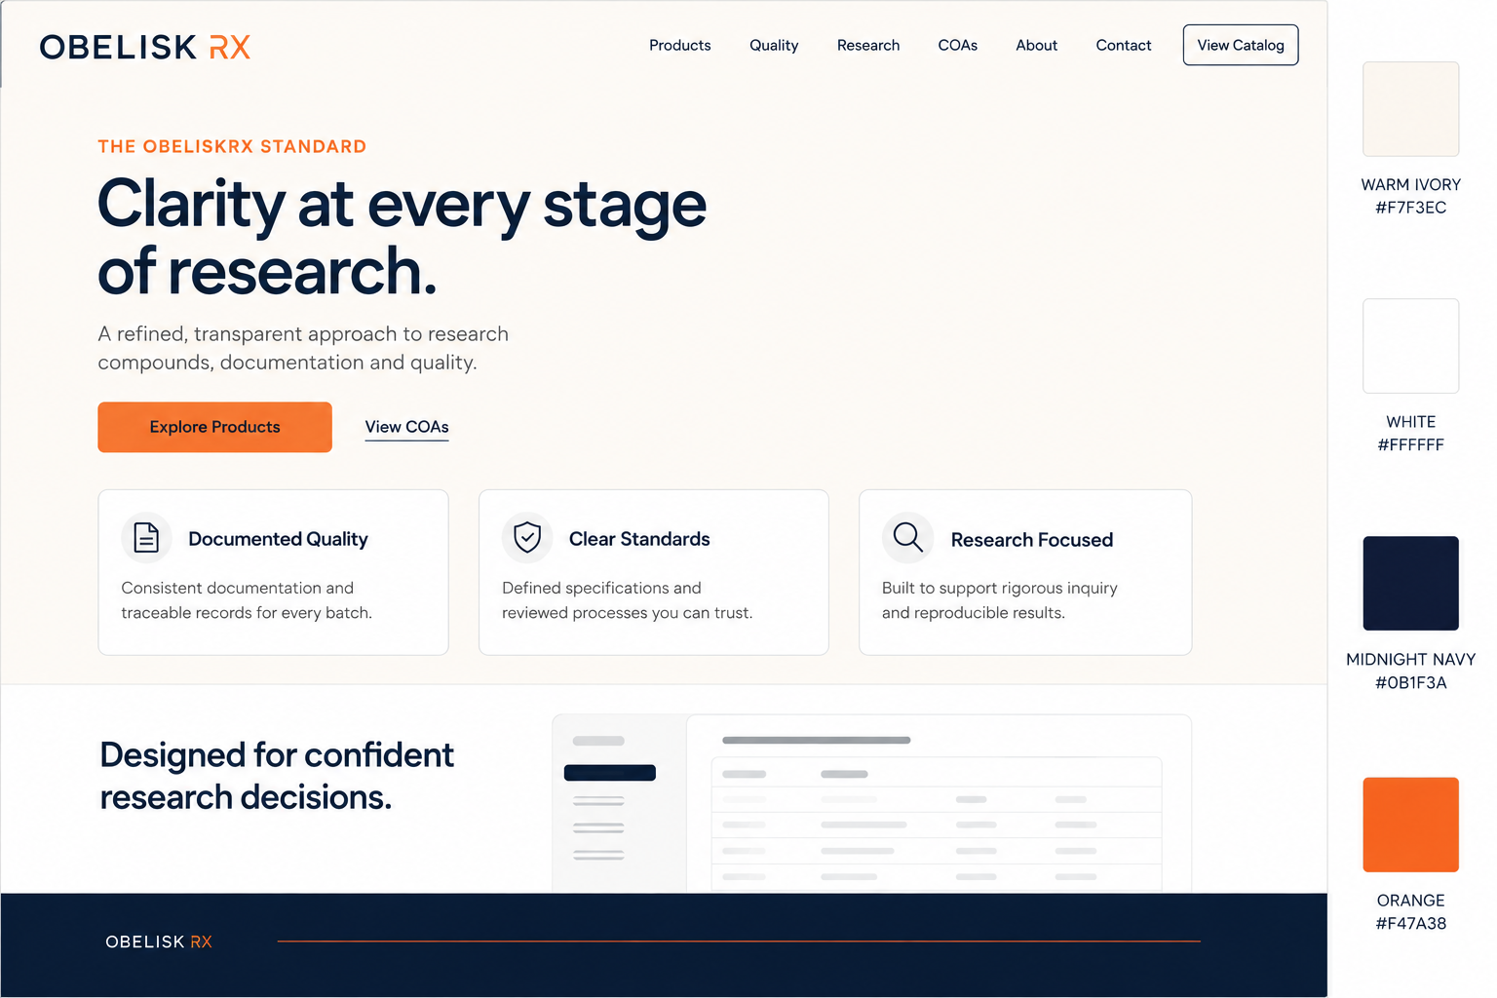
Role | Approved color | Usage
Primary canvas | Warm Ivory #F7F3EC | Most page sections and open content areas
Secondary surface | White #FFFFFF | Cards, tables and alternating sections
Structural dark | Midnight Navy #0B1F3A | Headings, footer and selected emphasis
Action accent | Victory Orange #F47A38 | Primary CTA, labels, active states and short accents
Target balance: 70% warm ivory/white, 20% navy/blue and 10% orange accents. Do not introduce extra beige or gray page backgrounds.

11. Imagery, Icons & Content Tone

Photography direction
- Use the approved abstract sunset only in the homepage hero and selected high-impact brand placements.
- For interior pages, favor real, clean laboratory environments, macro scientific textures and authentic materials only when imagery adds meaning.
- Favor natural side lighting with restrained warm highlights and cool shadows.
- Use shallow depth of field sparingly; preserve credibility and detail.
- Select diverse, professional researchers only when people add meaning. Avoid anonymous “doctor with clipboard” stock clichés.

Avoid
- AI-looking molecular scenes, glowing DNA tunnels, floating capsules and impossible laboratory setups.
- Beach, ocean, palm-tree or lifestyle sunsets; the approved hero is abstract and atmospheric.
- Repeating literal sunset imagery throughout clinical interior pages.
- Overly saturated orange-blue color grading, lens flares, chrome effects and excessive glow.
- Unverifiable medical claims, patient transformation language or imagery implying approved therapeutic use.

Icon system
Use one consistent outline icon family at 1.75–2px stroke, rounded joins, and simple geometry. Default icons should be navy or blue; orange is reserved for active or featured states.

Voice
Use | Avoid
Precise, calm and transparent | Hype, urgency and miracle language
Research-focused explanations | Consumer wellness promises
Short, confident headings | Dense jargon or overclaiming
Clear limitations and documentation | Vague “clinically proven” claims without evidence

12. Developer Handoff

CSS design tokens
/* ObeliskRX core tokens */
:root {
--orx-midnight: #0B1F3A;
--orx-blue: #174A7E;
--orx-sky: #6FA9D8;
--orx-orange: #F47A38;
--orx-amber: #FFB15A;
--orx-ivory: #F7F3EC;
--orx-white: #FFFFFF;
--orx-ink: #17212B;
--orx-muted: #5F6B76;
--orx-line: #D9E0E7;
--orx-gradient: linear-gradient(115deg, #0B1F3A 0%, #174A7E 38%, #F47A38 76%, #FFB15A 100%);
--orx-hero-fade: linear-gradient(to bottom, rgba(247,243,236,0) 0%, #F7F3EC 100%);
--orx-radius-card: 16px;
--orx-radius-button: 11px;
--orx-shadow: 0 10px 30px rgba(11,31,58,.08);
}

Asset delivery checklist
- Primary horizontal logo: SVG + transparent PNG
- Reversed white logo for the sunset hero and other dark backgrounds
- Icon/monogram: SVG + PNG; square favicon files
- Homepage, COA, Research and About Us hero images exported as WebP and JPEG fallback
- Separate mobile crop for every hero image
- Approved decorative gradient implemented in CSS
- Manrope and Inter loaded with display=swap and appropriate fallbacks
- Open Graph/social-sharing image sized 1200 × 630px
- Component states documented: default, hover, focus, active, disabled and error

Final QA before launch
- Check every page at mobile, tablet and desktop breakpoints.
- Run automated and manual accessibility testing, including keyboard navigation.
- Confirm orange is accenting action—not competing with product information.
- Confirm no substitute logo font, extra blue, extra orange or unapproved gradient has been introduced.
- Review all research and product claims with qualified legal/compliance counsel before publishing.

